Checkpoint1 :

**How does the web work?**

* Web servers and web browsers communicate via HTTP
* HTTP ensures that all parts of the web page are delivered
* Web browser decides how these items are displayed
* The backbone of the web is the network of *webservers* across the world. These are really just computers that have a particular type of software running on them - software that knows how to speak the HTTP protocol and knows which information stored on the computer should be made accessible through the web.
* It's possible to turn almost any computer into a webserver by downloading and installing server software though it's not recommended unless you know what you're doing!

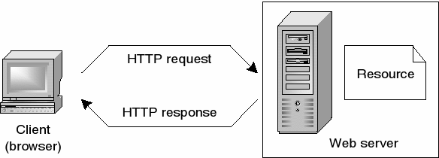

**Fig :** **How HTTP works retrieving a web page**

**What do you need to be a web developer?**

To become a Web Developer, you should have an understanding of HTML, CSS, and JavaScript. It's also recommended to learn about CSS and CSS frameworks. Developing these fundamental web development skills will give you the foundation and logic for communicating with programming languages.

**Why did you choose to learn web development?**

Nowadays web development is very necessary. Because there are lot of business running through websites which needs web developers and designers. Websites runs in every Application so it Increase the need of web development.